**Using the Concurrent function to test performance**

1. Sign into [Power Apps](https://make.powerapps.com/).
2. On the Home screen select **Canvas app from blank**.

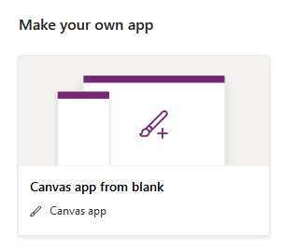

1. Name your app **New App** , format **Tablet** and click **Create**.

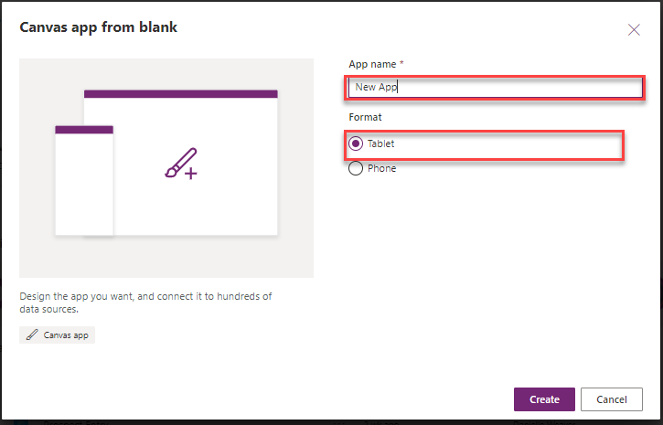

1. Select the **Insert** tab and add a button, name it button_Collection, set its **Text** property to Collection and set its **OnSelect** property to this formula:

PowerApps Formula

Set(varStart,Now());

ClearCollect(collectFruit,

{Name: "banana", Category: "fruit",AvgCost: .49},

{Name: "peach", Category: "fruit",AvgCost: 1.12},

{Name: "strawberry", Category: "fruit",AvgCost: 2.99},

{Name: "apple", Category: "fruit",AvgCost: 0.98},

{Name: "orange", Category: "fruit",AvgCost: 1.49},

{Name: "pear", Category: "fruit",AvgCost: 0.97},

{Name: "cantaloupe", Category: "fruit",AvgCost: 3.99},

{Name: "pineapple", Category: "fruit",AvgCost: 2.49},

{Name: "cherry", Category: "fruit",AvgCost: 4.99},

{Name: "mango", Category: "fruit",AvgCost: .99}

);

ClearCollect(collectVegetable,

{Name: "carrot", Category: "vegetable",AvgCost: .95},

{Name: "lettuce", Category: "vegetable",AvgCost: 1.69},

{Name: "potato", Category: "vegetable",AvgCost: 5.14},

{Name: "zuccini", Category: "vegetable",AvgCost: 1.99},

{Name: "broccoli", Category: "vegetable",AvgCost: 1.49},

{Name: "cabbage", Category: "vegetable",AvgCost: 2.48},

{Name: "celery", Category: "vegetable",AvgCost: 1.65},

{Name: "asparagus", Category: "vegetable",AvgCost: 2.99},

{Name: "kale", Category: "vegetable",AvgCost: 1.99},

{Name: "cauliflower", Category: "vegetable",AvgCost: 3.24});

Set(varSpeedCollect, Text(DateDiff(varStart, Now(), Milliseconds)));

1. Select the **Insert** tab and add a label, set its **BorderThickness** property to 3, rename it to SpeedCollect, and set its **Text** property to:

PowerApps Formula

varSpeedCollect

1. Press and hold **Alt Key**, and select the **Collection Button** control (This will create two collections named collectFruit and collectVegetable. The SpeedCollect label will display in milliseconds the amount of time it took to run the process information.).

[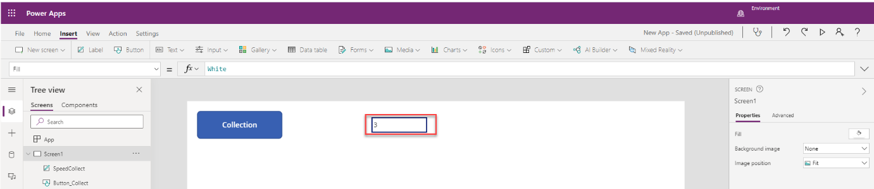](https://docs.microsoft.com/en-us/learn/modules/testing-performance-checks-powerapps/media/exercise-1-performance-collection.png#lightbox)

The lbl_SpeedCollect shows the amount of time it took to run the OnSelect process.

Now lets add the Concurrent function and check the performance.

1. Select the **Insert** tab and add a button, name it button_Concurrent, set its **Text** property to Concurrent and set its **OnSelect** property to this formula:

PowerApps Formula

Set(varStart,Now());

Concurrent(

ClearCollect(collectFruit,

{Name: "banana", Category: "fruit",AvgCost: .49},

{Name: "peach", Category: "fruit",AvgCost: 1.12},

{Name: "strawberry", Category: "fruit",AvgCost: 2.99},

{Name: "apple", Category: "fruit",AvgCost: 0.98},

{Name: "orange", Category: "fruit",AvgCost: 1.49},

{Name: "pear", Category: "fruit",AvgCost: 0.97},

{Name: "cantaloupe", Category: "fruit",AvgCost: 3.99},

{Name: "pineapple", Category: "fruit",AvgCost: 2.49},

{Name: "cherry", Category: "fruit",AvgCost: 4.99},

{Name: "mango", Category: "fruit",AvgCost: .99}

),

ClearCollect(collectVegetable,

{Name: "carrot", Category: "vegetable",AvgCost: .95},

{Name: "lettuce", Category: "vegetable",AvgCost: 1.69},

{Name: "potato", Category: "vegetable",AvgCost: 5.14},

{Name: "zuccini", Category: "vegetable",AvgCost: 1.99},

{Name: "broccoli", Category: "vegetable",AvgCost: 1.49},

{Name: "cabbage", Category: "vegetable",AvgCost: 2.48},

{Name: "celery", Category: "vegetable",AvgCost: 1.65},

{Name: "asparagus", Category: "vegetable",AvgCost: 2.99},

{Name: "kale", Category: "vegetable",AvgCost: 1.99},

{Name: "cauliflower", Category: "vegetable",AvgCost: 3.24}));

Set(varSpeedConcurrent, Text(DateDiff(varStart, Now(), Milliseconds)));

1. Select the **Insert** tab and add a label, set its **BorderThickness** property to 3, rename it to SpeedConcurrent, and set its **Text** property to:

PowerApps Formula

varSpeedConcurrent

1. Press and hold **Alt Key**, and select the **Concurrent Button** control (This will create two collections named collectFruit and collectVegetable. The SpeedConcurrent label will display in millisecond the amount of time it took to run the process information.).

